Camera

📘 Definition
# Source: AI Source: Provided by: [Data Path: Persons Table -> ID Column: 1, Name_En Column: Motasem Essam] -> From: [ChatGPT] on [5/2/2026]
A camera is a virtual device in computer graphics that defines what part of a 3D scene is visible and how it is viewed. It works like a real camera, but inside a computer-generated world.

📷 How a camera works
# Source: AI Source: Provided by: [Data Path: Persons Table -> ID Column: 1, Name_En Column: Motasem Essam] -> From: [ChatGPT] on [5/2/2026]
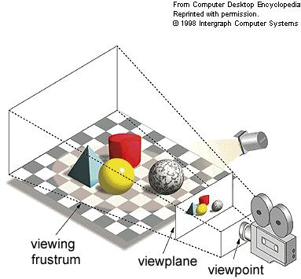
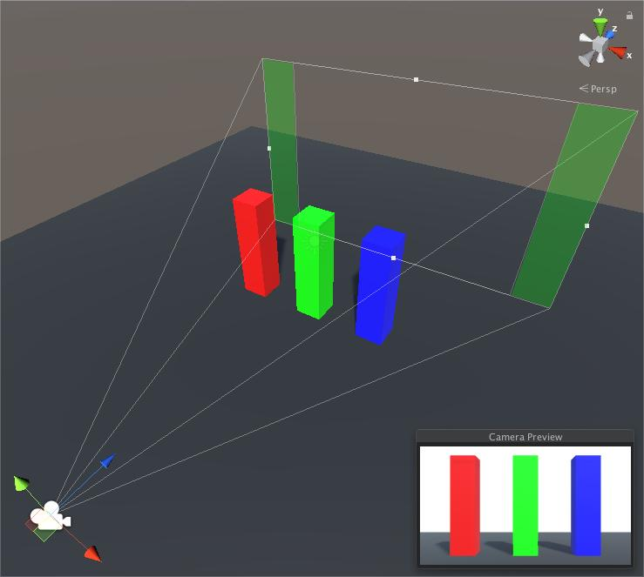
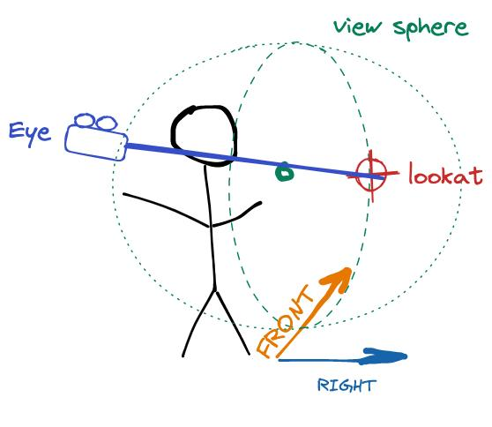
- It chooses the viewpoint of the scene
- It controls what the viewer sees or does not see
- It defines the angle, zoom, and perspective
- It converts a 3D scene into a 2D image

🧠 Simple example
# Source: AI Source: Provided by: [Data Path: Persons Table -> ID Column: 1, Name_En Column: Motasem Essam] -> From: [ChatGPT] on [5/2/2026]
Think of:
- 📱 Your phone camera taking a photo
- 🎬 A movie camera filming a scene
In 3D graphics, the camera decides what the final image will look like.

🎮 Camera in computer graphics
# Source: AI Source: Provided by: [Data Path: Persons Table -> ID Column: 1, Name_En Column: Motasem Essam] -> From: [ChatGPT] on [5/2/2026]
Cameras are used to:
- 🎮 Show the player’s view in video games
- 🎬 Frame shots in movies and animation
- 🧑‍💻 Control perspective in 3D modeling software
- 🖥️ Render final images from a scene

⚙️ Key features
# Source: AI Source: Provided by: [Data Path: Persons Table -> ID Column: 1, Name_En Column: Motasem Essam] -> From: [ChatGPT] on [5/2/2026]
- 📍 Has a position in 3D space
- 🎯 Has a direction (where it looks)
- 🔭 Has a field of view (zoom level)
- 🖼️ Creates the final visible image

🚀 In short:
# Source: AI Source: Provided by: [Data Path: Persons Table -> ID Column: 1, Name_En Column: Motasem Essam] -> From: [ChatGPT] on [5/2/2026]
Camera = a virtual viewpoint in 3D graphics that controls what part of the scene is seen and how it appears.

